Module 9:

Tracking and Updating Projects

Contents

Module Overview 1

Lesson 1: Overview of Tracking Projects 2

What is Tracking 3

Tracking Methods 4

Options that Affect Tracking 6

Best Practices 8

Lesson 2: Tracking Projects 10

Preparing a Task to be Tracked 11

Using Percent of Work Complete 13

Updating Tracking data at the Task level 17

Using Actual Hours of Work Complete Per Resource 22

Practice: Working with Tracking Methods 26

Lesson 3: Updating Milestones, Material and Cost Resources 27

Updating Milestones 28

Updating Material Resources 30

Updating Cost Resources 33

Practice: Updating Milestones, Material and Cost Resources 35

Lesson 4: Updating Project Status 36

Overview of the Tracking Cycle 37

Setting a Status Date 38

Reschedule Uncompleted Work 41

Getting the Project Back on Track 43

Practice: Updating Project Status 50

Summary 51

9

.

# Module Overview



The next step after the planning phase for the project is project execution. Once the execution of a project begins it is important to know how the project is progressing. Projects do not perform exactly as planned. It is important to know how much work has been accomplished and how much work is left to be performed to meet the finish date. The process of updating the project schedule to reflect the actual progress of a project is known as tracking.

In this module, we will discuss:

* Overview of tracking and tracking methods.
* How to enter tracking data for work resources.
* Updating costs, material and milestone tasks.
* Re-scheduling uncompleted work.

# Lesson 1: Overview of Tracking Projects





If projects performed exactly as planned, tracking would be simple and straightforward. Since this is not the case, accurate tracking becomes an essential part of managing the schedule of the project. In Project 2010 there are various tracking methods available. There are also option settings that should be considered when deciding your tracking methods.

In this lesson, we will examine:

1. Overview of tracking.
2. Tracking methods.
3. Project 2010 options that affect tracking.

## What is Tracking



Once a project has started to execute, it is important to manage the schedule of the project. This process is called Tracking.

When planning the project tasks, estimates were made for duration, work and costs. While performing a task, the task could take more time, less time, more resources, fewer resources, start late, finish late, start early, finish early or not performed at all. Tracking tasks in Project 2010 is the processes of letting the software know what work has been accomplished, so that Project 2010 can predict the end date of the project. Once the actual work values have been entered, the uncompleted work of the project will be re-scheduled as of a status date. This process is known as Statusing the Project.

In addition to updates to the actual work, other updates may include actual cost for cost resources and material resource assignment updates. Milestones should also be updated to reflect the dates the milestone was considered complete.

Selecting the right method of tracking for a project will be important. The reporting requirements of the stakeholders and goals for managing the project work will determine the type of tracking method selected for a project.

## Tracking Methods



Not all projects are the same. Each project has different requirements and goals for management of the schedule. Project 2010 provides three tracking methods that will accommodate most project requirements. The tracking method selected will depend on the reporting metrics the project reporting is required to produce.

**Best Practice:** For consistency, use only one tracking method per project schedule.

The three tracking methods are:

* Percent complete.
* Updating task data at the task level.
* Number of hours per resource per task per time period.

**Percent complete**

Project 2010 allows for two types of percent complete tracking:

* Percent **Duration** complete   
    
  % complete = Actual Duration/Duration
* Percent **Work** complete  
    
  % Work Complete = Actual Work / Work

Percent duration complete may be updated independently from percent work complete. By default, they will update at the same time. When a task is marked 100% duration complete, Project 2010 assumes that 100% of the work is also complete. The option to separate the two will be discussed in the next lesson.

Percent complete is the quickest and easiest tracking method. It is also the least accurate.

Best uses for Percent complete tracking are:

* Projects where the number of work hours are not tracked.
* Projects where flat amount contracts are used and only dates are managed.
* Projects where marking the tasks completed and knowing when the next task must start is the priority. Schedule management only.

**Updating task data at the task level**

Updating task data at the task level is updating duration or work for a task. This type of tracking will post actual information to a task without regard to specific resources that performed the work.

* If tracking work hours, the hours are posted to the task using the Work table of the Gantt Chart. If greater accuracy is required, entering actual start and finish dates will be helpful. While tracking hours, adjusting remaining work when necessary is essential. If remaining work is zero, the task will be considered completed.
* If tracking task durations at the task level, duration completed will be posted using the Tracking table of the Gantt Chart. If greater accuracy is required, entering actual start and finish dates will help drive the schedule. When tracking duration, adjusting remaining duration when necessary will be essential. If remaining duration is zero, the task will be considered completed.

Best uses for task level tracking are:

* Resource allocations are not the focus for schedule management.
* Focus is on remaining duration and hours.
* Projects that are looking to go a step higher in accuracy than percent complete but tracking resource hours is not realistic for the project.

**Number of hours per resource per task per time period**

When this tracking type is used, team members will submit their timesheets and hours will be entered per person per task per time period. Time periods are usually daily or weekly.

Best uses for Number of hours per resource per task per time period tracking are:

* Focus is on resource allocation.
* Focus is on costing and earned value calculations.
* Projects requiring specific higher level metrics.
* Obtaining estimating information to be used in creating future schedules

This tracking method will also require a more structured method of assigning work and collecting tracking information from the resources.

**TIP:**  When selecting a tracking method, determine the type of reporting data that will be requested by the stakeholders. A more detailed level of tracking will result in greater effort required to maintain the project schedule. Be careful not to make the project schedule become the project.

## Options that Affect Tracking



Project 2010 offers several options that will allow users control over how Project 2010 will react to the entered tracking data. These options can be set on a per project basis or applied to all projects. The options are discussed below:

**To view Scheduling options:**

* **File 🡪 Options 🡪 Schedule**

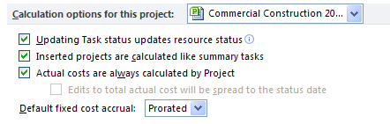

* **Updating Task status updates resource status** -
  + *Checked*: when a task is marked a percentage duration completed, the task will also update the percent work completed.
  + *Unchecked:* separates the update of percent work complete from percent duration complete. The values should be manually updated separately.
* **Actual costs are always calculated by Project.** 
  + *Checked*: Project will automatically calculate costs.
  + *Unchecked*: Costs are calculated manually.

**To view Advanced options for tracking:**

* **File 🡪 Options 🡪 Advanced**

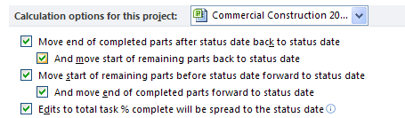

When using the options shown above, a Status date must be entered before tracking data is entered. Status date will be discussed in Lesson 4 in this module.

The first 4 options above, if checked will automatically reschedule uncompleted work to the status date as tracking data is entered. Unchecking these options allows the project manager to enter all tracking data and reschedule the uncompleted work manually.

**Edits to total task % complete will be spread to the status date** -

*Checked*: spreads the total percent complete to the project status date.

*Unchecked:* will distribute task percent completion to the end of the actual duration of the task.

## Best Practices



Best Practices of Tracking:

* Decide during the planning stages how tracking will be accomplished for a project.
* Avoid mixing tracking types within a project schedule other than marking milestones completed. When tracking types are mixed, the metrics will not contain consistant data.
* Use the Notes fields to notate information related to management of the tasks.
* Find out if there are standards within your organization that might direct you to one tracking method over another. The standards will likely addess the type of data that is required for status reports.
* Determine your method of data collection ahead of time. Set up a process to issue work to team members and collect actual values. The Resource Usage view can be altered to print per resource assignment sheets if necessary. A data collection method will help avoid losing tracking data and provide an audit trail.
* Entering tracking data can be a lot of work. For a small project using percent complete, it is manageable for the project manager to enter the data. As projects and teams increase in size the quantity of data becomes greater in volume, the project manager will need the help of team members to enter the tracking data. It is not recommended that team members work on the schedule directly. Project Server 2010 or Sharepoint will enable team members to enter their own tracking data for the project and free the project manager from having to enter the tracking data manually.
* Pick a standard and stick to it when using percent complete tracking. When someone says they are 58% complete on a task, what does that really mean? Applying structure to the percent completed values will allow them to become more meaningful. Increased value would also be derived from getting actual start and actual finish dates whenever possible. Below are a few proven percentage update schemas :   
  + 25 percent completed = the task has started
  + 50 percent completed = the task is well into progress
  + 75 percent completed = the deliverable was delivered
  + 100% percent completed = the deliverable was accepted
  + If you have shorter tasks or a short project, you might consider using 50% and 100% only.   
     - 50% when the task is started  
     - 100% when the task is completed and signed off
* Too much WBS detail could result in the schedule becoming another project of its own. The WBS is not a checklist but is a task list to manage. Keeping the WBS tasks at a higher level of detail will result in less work during tracking. If deeper detail is required, create checklists using other sources like Word, Excel and Sharepoint lists.

# Lesson 2: Tracking Projects



Tracking data updates should be performed using a regular weekly cycle. Typically, tracking data is collected from resources on Friday by close of work. Project managers update the data and re-schedule uncompleted work by noon or close of work on Monday, issuing new work assignments for the week. Longer length projects might use bi-weekly or monthly update cycles. It is important to establish an update cycle and keep it consistent for the duration of the project.

In this lesson, we will examine:

1. Preparing tasks to be updated.
2. Entering percent complete.
3. Enter task level updates.
4. Entering actual hours of work per resource.

## Preparing a Task to be Tracked



Once work begins on a project, the schedule has moved into the tracking phase of project management. When tasks are ready for tracking, the schedule is now used to provide information on how the project was performed. To prepare tasks to be tracked, the following actions should occur:

* Set a baseline for the tasks ready to be tracked
* Change the task types to Fixed Units

**Set a baseline for the tasks ready to be tracked**

As discussed in Module 6, baselines are optional but if you are using baselines in your schedule they should be set before tracking information is entered. It is important to baseline the project in order to compare project performance against planned performance (variance) as well as earned value calculations and lessons learned to improve future project planning.

**Change the task types to Fixed Units**

Task types will be an influential factor in the tracking of tasks, re-scheduling the uncompleted work and resource leveling. If distribution of resource allocations is a concern, the best task type to aid in these actions is Fixed Units.

When resources were assigned to tasks, the units quantity of the resource was adjusted based on the amount of the resource units needed for the task. It will be important that the quantity of the resource assigned to a task not change during re-scheduling of uncompleted work for the project to keep your assignment consistant.

Project 2010 provides a bulk task changing capability called Multiple Task Information. Select a range of tasks and then click on the Information icon to make changes to groups of tasks simultaneously.

To change the task type for all tasks ready to be tracked to Fixed Units:

* + 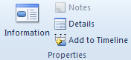Select all tasks ready to be tracked
  + Click Task 🡪 Information.
  + Click the Advanced tab.
  + Click the task type and select **Fixed Units**.
  + Click **OK**.

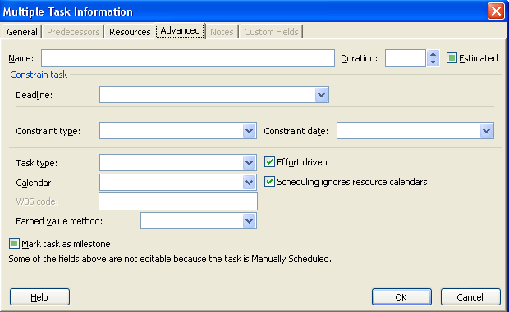

**TIP:**  *Use this method to do bulk changes to tasks and resources as necessary.*

## Using Percent of Work Complete



There are several different ways to update percent complete using Project 2010. It is important to select the method that will work best for you. Percent complete tracking is functions the same for automatic or manually scheduled tasks.

**NOTE:**  *All examples below have the automatic updates to status date options turned off to allow for manual rescheduling of work.*

Tracking percent complete buttons are located on the Task ribbon bar. These buttons are percent duration complete.

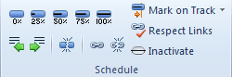

When marking a task percentage completed using these buttons, keep the following in mind:

* The task actual start date will use the value in the Start column. Planned Start will become Actual Start.
* The task actual finish date will use the value in the Finish column. Planned Finish will become Actual Finish.
* Each resource assigned to the task will do exactly as much work as originally scheduled, on the days they were scheduled to be performed, prorated for the percentage completed.

In the example below task 3 was marked 100% complete using the tracking buttons on the Task bar. The view is the Tracking Gantt in the top pane with the Task Form Work subview in the bottom pane. The Tracking Gantt is formatted to show the baseline as well as duration percent complete values on the Gantt bars. Note that the summary task is showing 17% of the work has been completed for the tasks included in the General Conditions summary. There is also a progress bar showing underneath the summary bar and a checkmark in the indicator column for task 3. The check mark in the indicator column reflects that the task is 100% completed. The resource was updated to show the same about of work completed as planned. Remaining work for the task is zero.

**To view the Tracking Gantt:**

* **Tasks 🡪 Gantt Chart 🡪 Tracking Gantt**

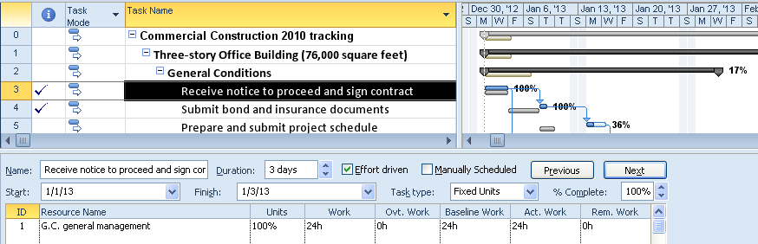

To remove the tracking information for a task:

* Click on the task.
* On the **Task** bar, click **0%** .

In the next example, task 4 started 2 days later than planned. It was also discovered, that additional time was going to be needed to complete the task. This information can be added to the task update information using the Update Task box.

To display the Update Task box:

* Click the task
* Click on Task ribbon 🡪 Mark on Track 🡪 Update Tasks

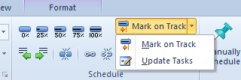

The Update Tasks box will be displayed:

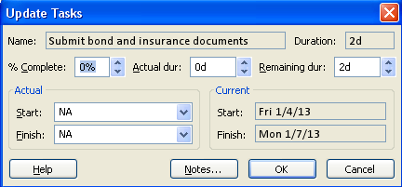

In the Update Tasks dialog box above, the actual start date, actual duration, % duration complete and the remaining duration may be adjusted. Entering an actual finish date will result in the task being considered 100% completed. This box will also give you access to the Notes field to be used to collect comments regarding how the tasks were performed. The note information is updated to the Task Notes field.

In the example below, Task 4 “Submit bond and insurance documents” has started 2 days late, 1 day of work was accomplished and remaining work was increased by 2 days. Total task duration is 4 days. The following information was entered in the Update Tasks dialog box:

* Start date – 2 days later that current start date
* Actual duration – 1 day
* Remaining duration – 3 days

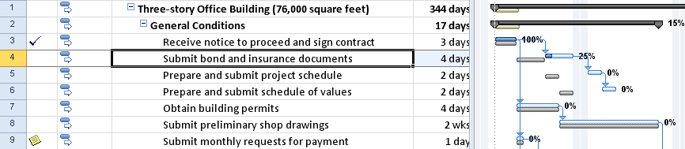

The result of the update information for task 4 is that the original 2 day task will now take 4 days. The task started 2 days late so it is off schedule compared to baseline. All related tasks are now scheduled later. The task has also been marked 25 % complete.

A new feature in Project 2010 allows updating tasks to be completed as planned. This feature will mark any tasks completed through the project status date. The Project Status date must be entered through Project 🡪 Project Information before marking tasks completed as planned. After the date has been entered click on the following:

* Select a **task** or **multiple tasks**
* **Task** 🡪 **Mark on Track**.

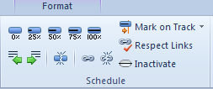

Another new feature in Project 2010 is the ability to update tasks using the Team Planner view. If tracking information is derived from resources, a resource might report on multiple tasks at once. The team planner view will allow for easy updating from the resource point of view.

In the example below, the G. C. Procurement resource is reporting tracking information for task “Obtain building permits” as 50% completed and starting 1 day late.

* Task 🡪 Gantt Chart 🡪 Team Planner



* Click the **task** to be updated.
* **Task** 🡪 **Mark on Track** 🡪 **Update Tasks**.
* Continue with directions for Update Tasks earlier in this lesson.

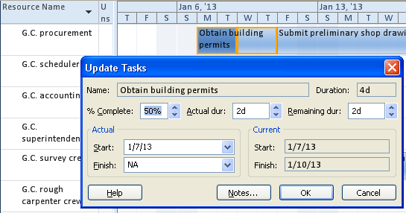

s

## Updating Tracking data at the Task level



Updating task level tracking information is tracking total work hours or duration for a task without concern for individual resource performance. Percent complete will be calculated as a result of entering work hours or duration for tasks.

When updating task duration collect this information from resources:

* Actual duration completed.
* Remaining duration.
* Actual start date (optional).
* Actual finish date (optional).

When updating task work collect this information from resources:

* Actual work completed.
* Remaining work hours.
* Actual start date (optional).
* Actual finish date (optional).

Use the Tracking table to enter tracking information for duration at the task level:

* **Task** 🡪 **Tracking Gantt Chart**.
* Right click in the upper left corner above the task numbers.
* Select the **Tracking** table (see below).

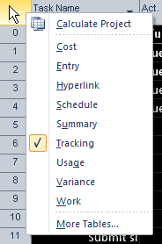

Tracking data was collected for Task 4 “Submit bond and insurance documents”.

* The task started 2 days late
* 1 day of work was completed
* The task will require an additional 2 days to complete.

Below is the task before tracking information is entered. Note the Rem. Dur or Remaining Duration column contains 2 days and Act. Dur. or Actual Duration is 0 days.

NOTE: *Column headings names have been shorten. Hover mouse pointer over column heading to see the complete column name.*

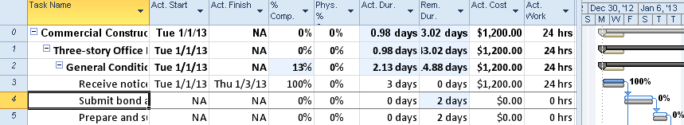

The following information was entered to update the task:

* Actual Start: task was planned to start on Friday, January 4 but it did not start until Tuesday, January 8. 1/8/13.
* Actual duration: 1 day.
* Remaining duration: 3 days.

Note that the task calculated 25% completed and $300 in Actual Cost. As a result of this update the project is off schedule from the baseline value. See the updated example below:

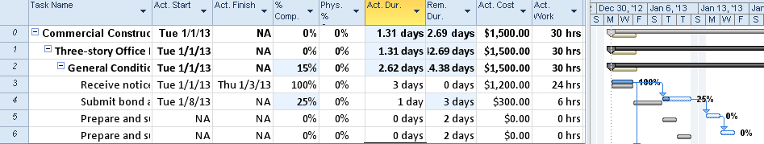

To enter tracking information for work at the task level, use the Work table:

* **Task** 🡪 **Tracking Gantt Chart**.
* Right click in the upper left corner above the task ID numbers.
* Select **Work**.  
    
  **Note:** *because every field in the table is a Work field, the word “Work” has been elimated from the column titles. Hover your mouse pointer over the column titles to see the complete field names.*

Task 5 “Prepare and submit the schedule” has been baselined for 20 hours of work. In the view below, no work has been completed on this task and % W. Comp. or % Work Completed column is shown as 0%.

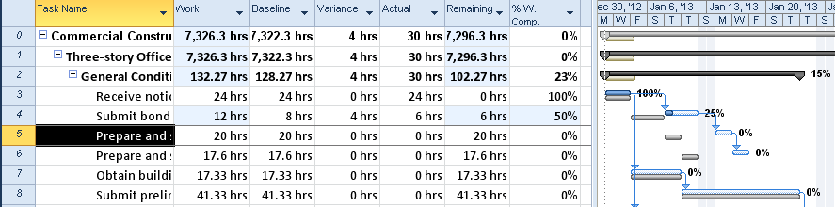

Data for work tracking for task 5 was collected and entered as follows:

* Actual work: 10 hours
* Remaining Work: to complete the task, 18 hours will be required. This is an additional 8 hours over the original estimate. 8 was added to remaining work.

The result of entering the work tracking data is:

* Task 5 calculated work to be 36% work completed for the task.
* Actual start date was not entered. The value in the Start column was used by Project 2010 as the actual start date which was January 13.
* Work has increased from 20 hours to 28 hours. The value of the work column is remaining work plus actual work.
* The Variance column for task 5 is showing 8 hours. This number is being calculated as the difference between Work and Baseline. A positive number means that more work is being done than what was originally baselined or planned for the task. A negative number will reflect less work than originally planned.

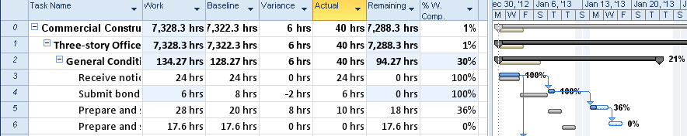

**NOTE:**  *Task 4 above shows remaining work at zero. This means the work for this task has been completed. As a result, the variance displays a negative value meaning the task required fewer hours than originally estimated.*

**TIP:** Actual Start and Actual Finish columns may be added to the Work table to allow date entry. Entering these values will help push your schedule forward more accurately and give you one location to enter time and actual dates.

Another view that can be used as an update view for actual work at the task level is the Task Usage view. Adding the actual work column to the right side of the view and adjusting the timescale density will give you flexiability in entering work tracking information.

To add the Actual Work column to the right side of the view:

* **Task** 🡪 **Gantt Chart** 🡪 **Task Usage**.
* **Format** 🡪 **Details**.
* Under **Available fields on the left**, click **Actual work**.
* Click **Show** – Actual work will move to **Show these fields on the right**.
* Customize Font, Cell background and Pattern may also be modified.

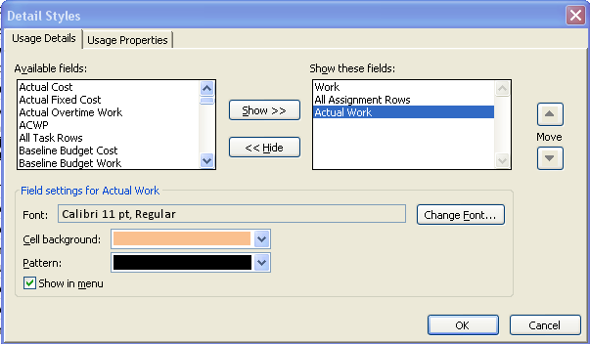

In the example below, the task “Set up site office” is scheduled to require 27 hours of work assigned to 2 resources.

Below is the Task Usage view of this task before updating tracking data. Note that the Actual Work columns has been added to the view.

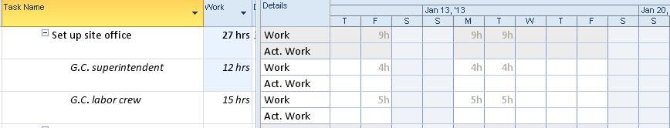

* The task has started 1 day late.
* 7 hours of work was accomplished on day 1.

Below is the result of entering the tracking data. The 7 hours of work entered is indicated. Note how the remainder of the uncompleted work was rescheduled for the resources.

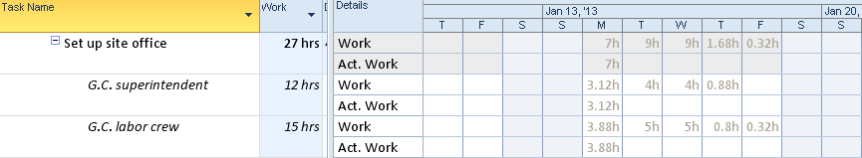

## Using Actual Hours of Work Complete Per Resource



Updating resources for hours per task may be performed from several different views. Work may be entered for a resource to a task in a lump sum or entered at the per day or the per week level. How data is entered will determine which view should be used for this purpose.

**To enter hours on a task for a resource:**

* **Task** 🡪 **Tracking Gantt**.
* **Task** 🡪 **Details**.
* Right click in the bottom pane 🡪 **Work**.

The following split screen will appear. In the example below, the “Install temporary power” task has been selected. This view shown is before actual work has been updated for the task. Note the Detail Task Form shown in the lower pane has more detail in the form header than the Task Form used in previous views. On the left side of the Detail Task Form multiple dates may be seen by selecting different date options. Currently this task is scheduled to start on January 4, 2013.

To turn on the Detail Task Form:

* Task 🡪 Gantt Chart
* Task ribbon 🡪 Click on Details

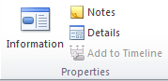

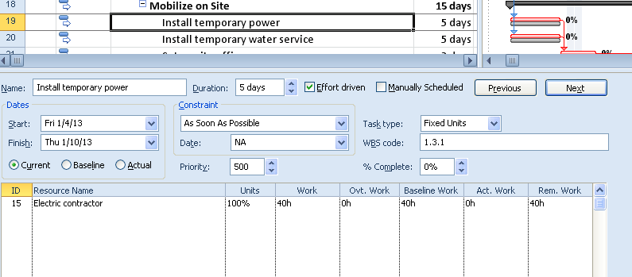

Hours tracking data was collected for this task as follows:

* Resource started the task 2 days late.
* Resource completed 10 hours of work on the task.

The tracking data was entered as follows:

* Under **Dates** on the left side of the lower pane, Actual dates were selected and a late start of January 8 was entered as the actual start date.
* 10 hours was entered into the Actual Work column – Work subview.
* OK was clicked to complete and update the transaction.

The update is shown below. The task is 25% completed and remaining work is 30 hours for this resource assignment.

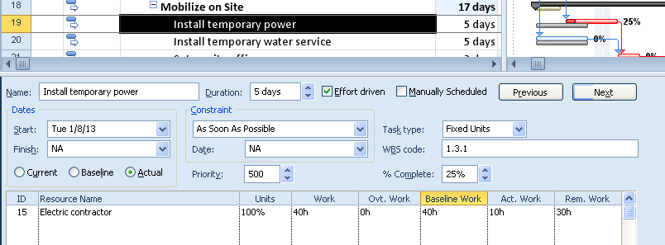

The current schedule for this task can be viewed by right clicking in the bottom pane and selecting Schedule. The new scheduled completion date is January 14, 2013 for this task. Multiple resource updates may occur at the same time. If resources are not available during the new scheduled dates, the work will move out in time until the resource has the open availability time to perform the task.

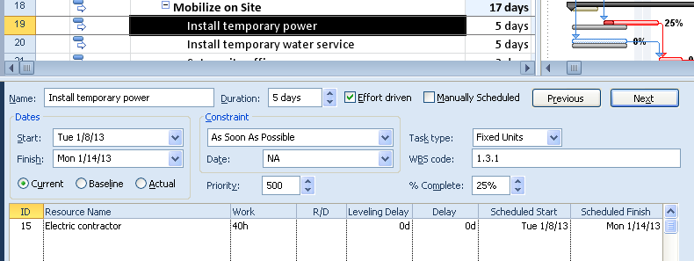

The most detailed level for updating the number of hours for a resource within a time period is the Resource Usage view. Use this view to update hours at a per day or per week timescale density. By default, the standard Resource Usage view does not include the Actual Work column. This column should be added using the method previously stated.

Below is a view of the Resource Usage view showing G. C. Procurement’s assigned work with the actual work column showing. The time scale is reflecting a per day setting. The timescale may be adjusted in the lower right corner by using the zoom slider. A per week setting is a more comfortable timescale for many users. Note that the task assignment “Obtain building permits” is scheduled to complete on January 9 and the successor task assignment “Submit preliminary shop drawings” is schedule to start on January 10.

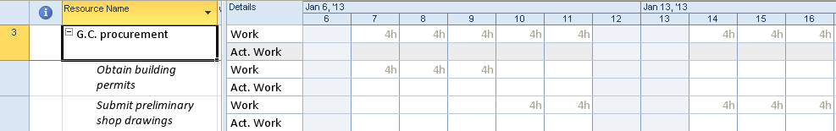

Tracking data for the G. C. Procurement resource was collected as follows:

* The work that was scheduled to start on January 7, actually started on Jaunary 8.
* 4 hours was completed on January 8 and 3 hours was completed on January 9.

The data collected was entered as follows:

* 4 hours in actual work on January 8
* 3 hours of actual work on January 9

After the actual values were entered, the uncompleted future work was re-scheduled. The work for the “Obtaining building permits” task was re-scheduled to be worked on January 10, 11 and 12. The new start date for the “Submit preliminary shop drawings” task was rescheduled to start on January 14. Note that the resource is limited to working 4 hours per day. The result is shown below:

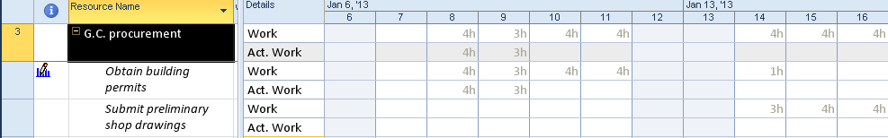

G. C. Procurement was asked to work more time to bring the schedule closer to the original schedule. Additional tracking information was collected:

* G. C. Procurement worked 7 hours on January 10. It was determined that the task was completed.

The data was entered as follows:

* January 10 Actual work – 7 hours
* January 11 Work – 0. Entering a zero in the Work column will remove the remaining work for the assignment. The assignment is considered complete.

The orginal completion date of the “Obtain building permits” task was January 9 and was not met but the task was completed on January 10. The dependent task “Submit preliminary shop drawings” that was rescheduled to start on January 14 is now scheduled to start on January 11. The result is shown below:

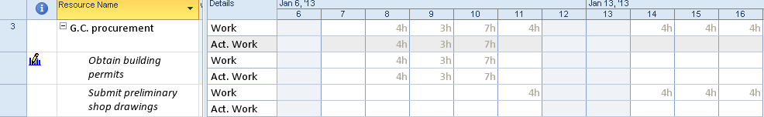

NOTE: *The icon in the indicator column notes that the assignment has been edited.* 

Per resource time collection and entry can be a lot of detailed work. If you chose to use this tracking method, consider using MS Project Server which would allow resources to enter their own tracking data as well as administrative and other time data. The project manager would then approve the actual work and update the project schedule.

## Practice: Working with Tracking Methods



*The Practice page is where you write detailed instructions for completing work listed as Exercises.*

*Type the Exercise Title and write a brief summary what the student will be doing in the exercise. Then list your ideas what they will be doing.*

*SAMPLE*

*In this practice, you will create a Project Server Authentication profile and then configure the local cache settings in Project Professional 2007.*

*Exercise 1: Create Project Server Authentication Profile*

*In this exercise you will create Project Server authentication profile to connect to the Project Web Access site.*

Perform the following exercise on the PS07 virtual machine.

1. *From the* ***Start*** *menu, click* ***All Programs*** *🡪* ***Microsoft Office*** *🡪* ***Microsoft Office Tools*** *and click* ***Microsoft Office Project Server 2007 Accounts****.*
2. *In the* ***Project Server Accounts*** *dialog box, click* ***Add****.*
3. *In the* ***Account Properties*** *dialog box, and complete the following settings and click* ***OK****.*

|  |  |
| --- | --- |
| *Setting* | *Perform the following:* |
|  | |
| *Account Name* | *Type* ***Project Server*** |
| *Project Server URL* | *Type* ***http://epm/pwa*** |
| *When connecting* | *Select* ***Use Windows user account*** |
| *Set as default account* | *Select check box* |

# Lesson 3: Updating Milestones, Material and Cost Resources



Milestones, Material Resources and Cost Resources should also be tracked using Project 2010. When cost and material resources were assigned during planning, values were updated to the baseline. Tracking these values will provide the variance of baseline vs actual values. When tracking these types of resources, having a standard process for collecting actual values will be helpful. Tracking milestones will help move your project schedule forward toward your ending date.

In this lesson we will discuss:

1. Updating milestones.
2. Updating material resource assignments.
3. Updating cost resource assignments.

## Updating Milestones



Milestones are points in time. They are also short term goal dates within a project schedule that need to be achieved. Frequently, milestones are also the acceptance of work or a management approval. These dates should be noted. Since milestones are linked within the network of tasks, the achievement dates will help push the schedule forward. Marking milestones complete as of a specific date will support this effort as well as providing for variance calculations.

Milestones may be marked completed in several ways:

**Update milestones using the Task Tracking table:**

* **Task** 🡪 **Gantt Chart**.
* Right click in the box above the task ID’s.
* Select **Tracking**.  
    
  OR
* **View** 🡪 **Tables** 🡪 **Tracking**.

Task 7 below, is a milestone. It was planned to be completed on May 7.

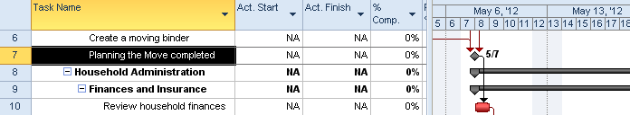

This milestone was not completed until May 11. Following the milestone, is a successor task, Review household finances, which was scheduled to start on May 7 and will now be delayed. If only the finish date for a milestone is entered, the start date will remain the same as the value in the Start field (May 7) and the task would appear as 4 days of duration. By entering the same date for the Actual Start and Actual Finish fields, the task retains the look of a milestone.

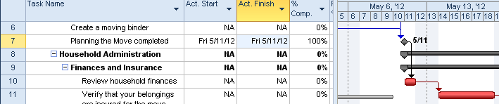

An alternate view that can be used to update tracking data for milestones is the Update Task box:

**To display the Update Tasks box:**

* **Task** 🡪 **Gantt Chart** 🡪 **Tracking Gantt**.
* Click the task to be updated.
* **Task** 🡪 **Mark on Track** 🡪 **Update tasks**.

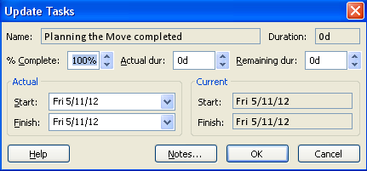

Using the percent complete buttons is an effective method of updating milestones. This method was described earlier. However, using these buttons will assign the current values of the Start and Finish fields to the Actual Start and Actual Finish fields. If the task is off schedule, it is recommended that one of the 2 eariler mentioned methods are used because you will have an opportunity to enter alternate dates.

## Updating Material Resources



Material resource assignments are the consumables of the project. When creating an assignment for a material resource, the estimated number of items required is entered. Tracking material resources will be entering the number of the consumable that was actually consumed within the project.

For example: An assignment using a material resource called “Paint” was assigned to a task called “Paint walls and woodwork” with an estimate of 10 gallons of paint and using the work resource Painting contractor. A baseline was set for this task.



After the task was completed, it was discovered that 12 gallons of paint were used to complete the task. 12 gallons of paint must be updated to the task to track the difference and to update the value into the actuals.

Below is the Task Entry view showing the Paint walls and woodwork task before update of the material resource. The Work subview is showing in the bottom pane.

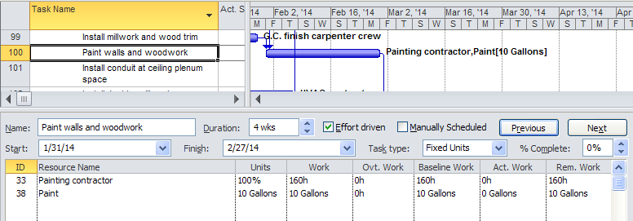

To update the material resource value, enter the number of actual units of the consumable in the actual work column. 12 was entered into the actual work columns. Note that the baseline is 10 and remaining work is zero. Total work and units has been increased to 12. Below is a view of the result.

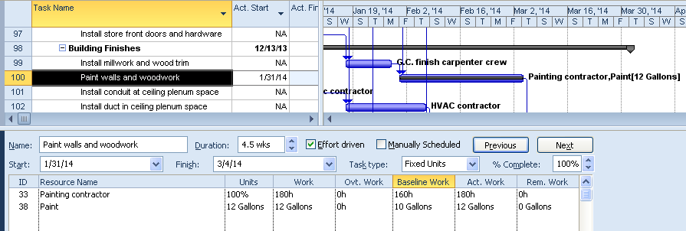

The increased number of items will result in an increase in cost for the materials.

To view the Cost subview in the bottom pane

* Right click in the bottom pane.
* Select **Cost**.

Below is the view showing the difference of cost between the Baseline Cost and Actual Cost values for the material resource.

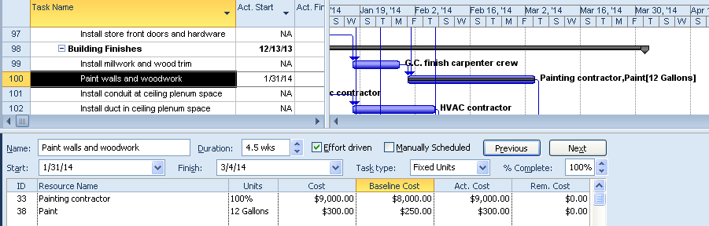

## Updating Cost Resources



Cost resources are resources used to add additional estimated costs to tasks. These costs will roll up into the summary and project summary tasks. The values of the cost resources will also become part of the baseline value for the project. Assignments are created with a cost estimate. Actual costs are tracked into the project schedule as information becomes available.

Continuing to use the Task Entry view, below is a view of an assignment with $4,000 of estimated travel costs. Since the baseline was saved the estimated costs have been included in the baseline.

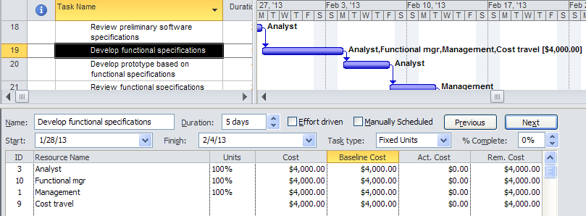

Travel expense reports were submitted after the task was completed. The actual cost of the travel expenses was $4,225.00. The view below is the result of the task being marked 100% complete. Note that the Actual Cost value for the cost resource was not updated.

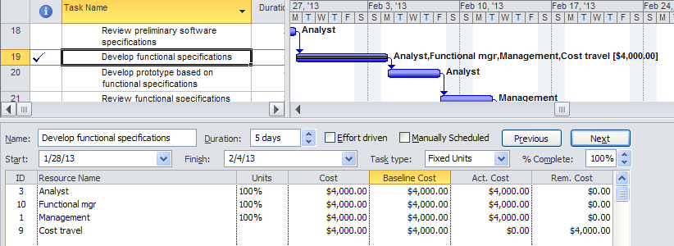

Costs are updated separately. Below $4225.00 was entered in the Actual Cost column and OK was clicked to update the transaction. See result below.

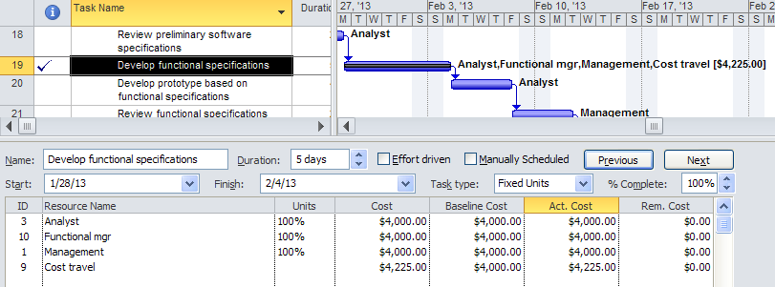

As an alternate view to update costs, the actual cost may be entered using the Resource Usage or Task Usage views by adding the Actual Cost column to the right side of the view.

**NOTE:** *If the task had been baselined and the estimated cost is greater than the actual cost, zero out the remaining cost field for the assignment.*

## Practice: Updating Milestones, Material and Cost Resources



*The Practice page is where you write detailed instructions for completing work listed as Exercises.*

*Type the Exercise Title and write a brief summary what the student will be doing in the exercise. Then list your ideas what they will be doing.*

*SAMPLE*

*In this practice you will create a Project Server Authentication profile and then configure the local cache settings in Project Professional 2007.*

*Exercise 1: Create Project Server Authentication Profile*

*In this exercise you will create Project Server authentication profile to connect to the Project Web Access site.*

Perform the following exercise on the PS07 virtual machine.

1. *From the* ***Start*** *menu, click* ***All Programs*** *🡪* ***Microsoft Office*** *🡪* ***Microsoft Office Tools*** *and click* ***Microsoft Office Project Server 2007 Accounts****.*
2. *In the* ***Project Server Accounts*** *dialog box, click* ***Add****.*
3. *In the* ***Account Properties*** *dialog box, and complete the following settings and click* ***OK****.*

|  |  |
| --- | --- |
| *Setting* | *Perform the following:* |
|  | |
| *Account Name* | *Type* ***Project Server*** |
| *Project Server URL* | *Type* ***http://epm/pwa*** |
| *When connecting* | *Select* ***Use Windows user account*** |
| *Set as default account* | *Select check box* |

# Lesson 4: Updating Project Status



Once the tracking information has been entered, the schedule should be updated to reflect the current status of the project. The process of statusing a project is rescheduling unfinished work as of a date in time to reflect the current estimated timeline of the project. Many project managers are concerned about rescheduling uncompleted work because their target dates might shift. It is important to discover sooner rather than later if there is a problem reaching your target dates.

Project Management is both an art and a science. Knowing what buttons to push is the science. Knowing how to manage a project and deliver it on time is an art. The art is developed through experience. The science can help the Project Manager perform more efficiently by providing more information to make better decisions.

In this Lesson, we will discuss:

1. The update cycle.
2. Setting a status date.
3. Rescheduling uncompleted work.
4. Getting the schedule back on track.

## Overview of the Tracking Cycle



Regular project status updates will help keep your project on schedule. If an organization has a PMO (Project Management Organization), they might have policies governing project status updates as part of their process. Most organizations using Project Server have policies in place that dictate the frequency of the status updates. Typically, project managers use a weekly update cycle to help keep their projects on track to meet their milestones and target dates.

A regular weekly cycle might look like this:

* Issue work assignments on Monday morning for the week.
* Resources work on the assignments during the week.
* Collect actual work values by close of business on Friday for work which occurred during the week.
* Enter actual values into project schedule and reschedule uncompleted work.
* Evaluate the schedule and make adjustments.
* Reissue new assignments by noon the following Monday.

Steps to achieve this update cycle using Project 2010 are below:

1. Actual values are collected from the resources.
2. The actual values are updated into Project 2010 for all resource types.
3. A status date is entered.
4. Uncompleted work is re-scheduled based on the status date.
5. Make any changes and adjustments to help get the project back on track.
6. New resource assignments are issued to resources.

In the absence of an organizational policy, consider establishing a frequency of how often statuses are completed tied to the length of the project schedule, for example:

* 1 month duration - status 2 to 3 times a week.
* 6 months duration - status weekly.
* 2 years duration – status monthly for the first 6 months and increase frequency as the time gets closer to the end of the project.

## Setting a Status Date



The Status Date is the date used as a completed through date of when work is to be rescheduled. The Status Date will represent a timeframe where all uncompleted work in the past will be moved and rescheduled in the future. Try to always use the same day of the week for each status update. If using the regular Monday through Friday cycle, it would be helpful to always select Sunday as the reschedule date. The uncompleted work will be rescheduled starting the day after the date selected as the Status Date.

Below is a small section of a project schedule with tracking data entered and shown using the Tracking Gantt view.

* The project start date is January 14.
* The milestone goal date for this section was January 24.
* The current projected ending date for this group of tasks is January 28.
* Current date is January 28 and not all work was completed as expected.

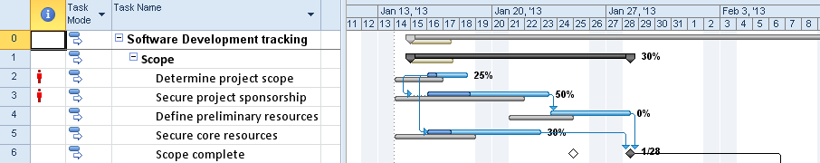

To reschedule the uncompleted work as of Monday, January 28, the Status Date for this timeframe will use Sunday, January 27. That date was chosen because work should be rescheduled starting on Monday, January 28 or the day after the Status Date. Below is a view of the Project Information dialog box with a Status Date of January 27 entered.

To enter the status date:

* **Project** 🡪 **Project Information**.
* Enter Status Date.
* Click **OK**.  
    
  - OR -
* **Project** 🡪 **Status Date**.

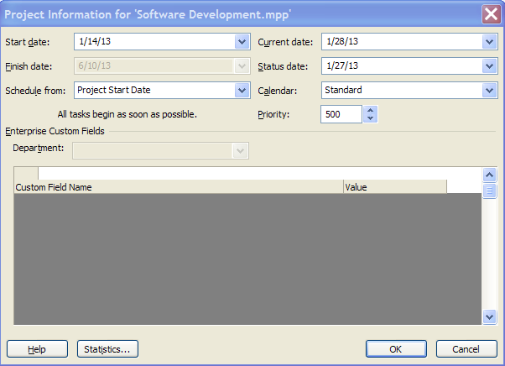

By default, the Status Date is not visible on the Tracking Gantt view.

To add the Status date line to the Tracking Gantt view:

* **Tasks** 🡪 **Gantt Chart** 🡪 **Tracking Gantt**.
* **Format** 🡪 **Gridlines**.
* **Line to change** 🡪 **Status Date**.
* Type (pick a line style).
* **Color** – select a color.
* Click **OK**.

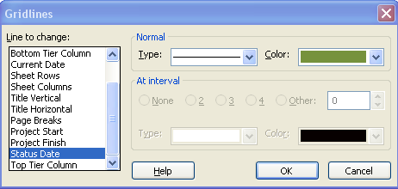

Note the vertical line indicating the Status Date in the view below.

**NOTE**: *If Current Date and Status Date are the same, the Current Date line indicator will be visible and the Status Date indicator is hidden.* *By default, the Current Date line is orange.*

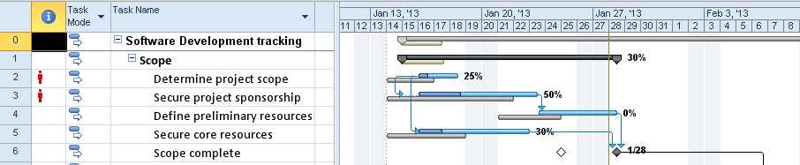

## Reschedule Uncompleted Work



Once a Status Date is entered, the uncompleted work may be rescheduled using the Update Project dialog box.

To view the Update Project dialog box:

* **Project** 🡪 **Update Project**.
* Click **Reschedule uncompleted work to start after**.
* Click **OK**.

Tasks may be updated by a select group of tasks or the entire project.

**NOTE:** if the Status Date was entered using the Project Information dialog box, the date is shown in the Update Project dialog box and will be seen on the formatted Gantt Chart as discussed in the previous lesson. If the Status Date is entered through the Update Project dialog box, the Status Date will not be visible on the Gantt Chart.

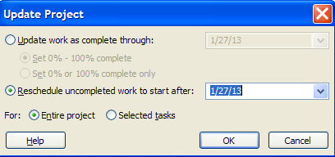

Once work is rescheduled all completed work is in the past. All work remaining to be completed is moved to the right of the Status Date or in the future. The projected ending date for this group of tasks is now February 4.

The result of rescheduling work is shown on the Tracking Gantt below:

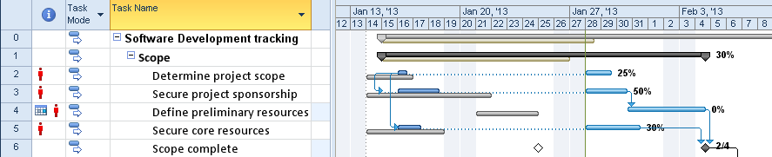

Project 2010 has a new feature called “Mark on Track”. When this feature is applied to a task, the task will be marked completed up to the Status Date of the project. In the example below tasks 3 thru 7 are scheduled to be completed by May 1. The Status Date is set to April 29. The work has been completed as planned. Below is a view before the tasks are Marked on Track.

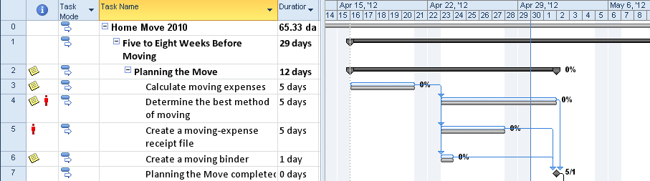

To mark tasks 3 thru 7 completed on track:

* Select the task or tasks to be updated.
* **Task** 🡪**Mark on Track**.

Task 3 and 6 is marked 100% completed. Task 4 and 5 are 60% completed. The summary task for this group of tasks reflects that the grouping is 75% completed. As you can see, the uncompleted work was not moved to the right side of the Status Date line.

The result is shown below:

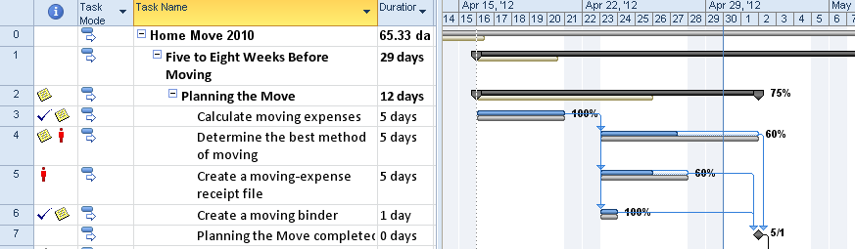

## Getting the Project Back on Track



Once the work of the project is rescheduled, the next step is to adjust tasks based on work completed. When tasks move to the future, resources will be rescheduled using resource availability. Constraints, particularly finish type constraints, will move forward to a date and create scheduling errors. Having a baseline in your schedule will be very helpful in knowing how far off original schedule your project is performing.

Project 2010 provides many views to see information about what is occurring with a project. Techniques for shortening the schedule, resource leveling and other best practices were discussed in Module 7. Those techniques should be applied here to help get the schedule back on track. After decisions regarding adjustments to the schedule are made, new resource assignments should be issued.

The following is a list of views, columns and tables designed to help you see how the project is performing:

* Detail Gantt – slippage.
* Adding slippage to the Gantt chart.
* Changing formatting of late tasks.
* Tracking Gantt.
* Variance.
* Resource Leveling.
* Negative slack.
* Filters & Groups.

**The Detail Gantt view:**

This view is designed to show slippage of tasks from the baseline schedule. It will show the difference between the baseline and the number of days/weeks the task has slipped. The slippage calculation is (Baseline Start – Start). The slippage will display as lines extending from the left of the Gantt bars. This view will also show where slack exists in the schedule, and display as lines extending from the right of the Gantt bars.

In the view below, link lines have been turned off to get an uncluttered view of the Gantt bars. Turning off the link lines is temporary and can be turned back on as needed.

**To turn off link lines:**

* **Format** 🡪 **Layout** 🡪 **Turn off the link lines** 🡪 **OK**.

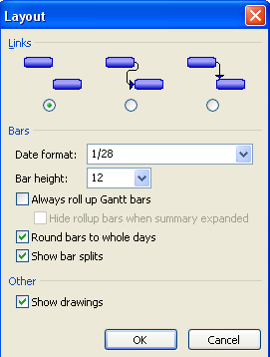

In the Detail Gantt view below, task 3 has slipped 3 days from the original plan but it is a non-critical task and can slip 3.5 days before affecting the end date of the project.

**To show the Detail Gantt view:**

* **Tasks** 🡪 **Gantt Chart** 🡪 **More views** 🡪 **Detail Gantt** 🡪 **Apply**

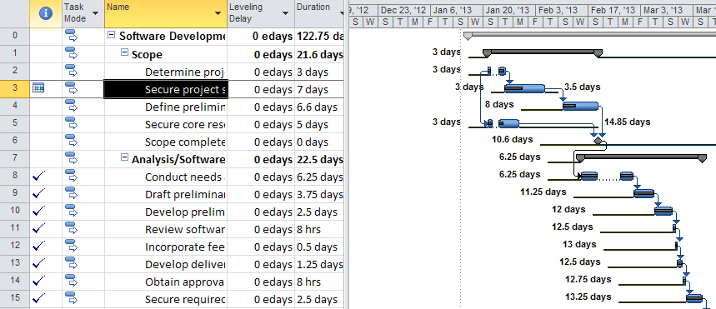

Project 2010 has the ability to add slippage bar indicators to any Gantt view. The option will also allow formatting Gantt charts with any of the 11 available baselines.

**To add slippage to a Gantt Chart view:**

* **Task** 🡪 select a **Gantt Chart** style view.
* **Format** 🡪 **Slippage** 🡪 select baseline to use for the view.

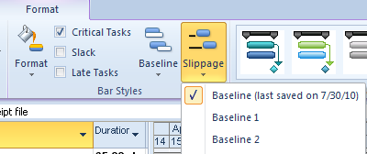

Below are the same tasks as above shown in the Gantt Chart view with the link lines turned off showing just slippage for the tasks. Note that the number of days is not showing as in the Detail Gantt view above. Slack could be added to this view by clicking on the Slack check box on the Format tab.

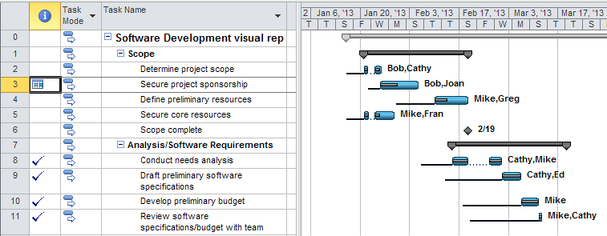

Tasks that should have been completed, based on the Status Date can be formatted to indicate that they are late. In the view below several tasks are running late compared to the Status Date. When clicking on the “Late Tasks” option, the late tasks will display and are formatted in black. Late tasks will look very similar to baseline formatting.

**TIP**: *Changing the formatting color for late tasks will help eliminate confusion when viewing the Gantt Chart.*

To format Gantt bars to indicate late tasks:

* **Task** 🡪 **Gantt Chart** 🡪 **Tracking Gantt**.
* **Format** 🡪 **Late Tasks**.

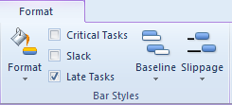

The late tasks are highlighted below.

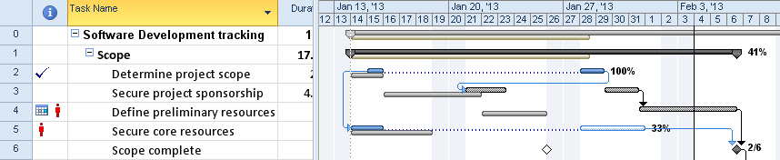

The Tracking Gantt will also be helpful to show which tasks are off schedule from the baseline plan. Use this view during tracking to show task percent complete and actual vs baseline variances for tasks.

**To view the Tracking Gantt:**

* **Tasks** 🡪 **Gantt Chart** 🡪 **Tracking Gantt**.

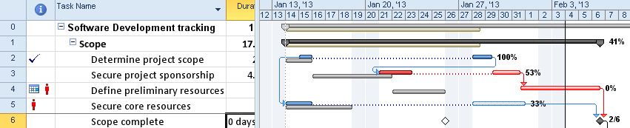

**Variance:**

Checking the variance between baseline and planned dates is very useful in discovering how far off original schedule your project is performing. The Task Variance table is designed to help identify the variances.

Looking at the Start Variance and Finish Variance columns:

* Zero means the task is progressing exactly as planned.
* A Negative number indicates the task is ahead of schedule.
* A Positive number indicates that task is behind schedule.

The Variance table is shown below with the variance columns indicated.

**To view the Variance Table:**

* **Tasks 🡪 Gantt Chart**
* Right click in the upper left corner above the task ID’s
* Select **Variance**

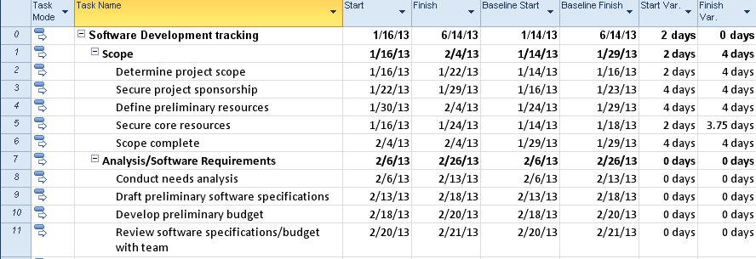

**Resource Leveling:**

After a project has been rescheduled, resources should be checked for overallocations that might have resulted from the rescheduling process. If overallocations exist, consider leveling the project schedule. Refer to the lessons regarding Resource Leveling in Module 7. Views that will help identify resource overallocations are:

* Gantt Chart indicator column – red person symbol
* Resource Sheet – resources displayed in red
* Resource Usage view – detail of the resource assignments and red names
* Resource Allocation view – Resource Usage/Leveling Gantt split view
* Team Planner – see where resources are assigned and level, look for red lines

Another quick check to see variances is the Project Statistics dialog box. The Project Statistics box displays a snapshot of where you started, how much work has been accomplished and how much work is left to be accomplished. The values in this box are also available in a printed report that will be discussed in Appendix B. In the example below, a variance of 2 days in the Finish column means that the project is running 2 days late.

**To view the Project Statistics dialog box:**

* **Project 🡪 Project Information 🡪 Statistics**

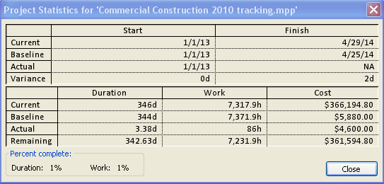

**All tables can be grouped and filtered.**

Useful groups to help manage tasks during schedule analysis include:

* **Incomplete and complete tasks**
* **Automatically and Manually scheduled tasks -** this grouping will be important if a mixture of scheduling modes has been used. Manually scheduled tasks are treated similar to automatically scheduled tasks during tracking. However, manually scheduled tasks might not have relationships and they are tasks that will still need to be considered as part of the timeline and critical path of the project.
* **Milestone –** displays milestone status in comparison to goal dates.
* **Status -** groups tasks by the status field. The status field is automatically calculated setting a value for the task as Complete, On Schedule, Late or a Future Task. See below for an example of status grouping:

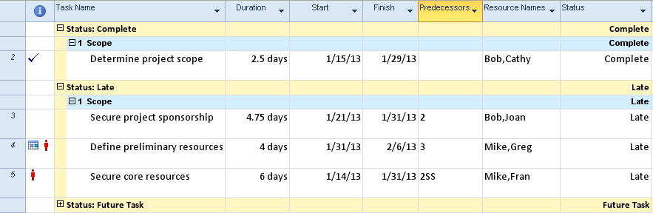

Useful filters to help manage tasks during tracking include:

* Critical
* Milestone
* Incomplete tasks
* Tasks using Resource
* Date range
* Late tasks
* Should start by (date entered)
* Should start by/finish by
* Slipped/Late/Progress
* Slipping tasks
* Unstarted tasks

## Practice: Updating Project Status



*The Practice page is where you write detailed instructions for completing work listed as Exercises.*

*Type the Exercise Title and write a brief summary what the student will be doing in the exercise. Then list your ideas what they will be doing.*

*SAMPLE*

*In this practice you will create a Project Server Authentication profile and then configure the local cache settings in Project Professional 2007.*

*Exercise 1: Create Project Server Authentication Profile*

*In this exercise you will create Project Server authentication profile to connect to the Project Web Access site.*

Perform the following exercise on the PS07 virtual machine.

1. *From the* ***Start*** *menu, click* ***All Programs*** *🡪* ***Microsoft Office*** *🡪* ***Microsoft Office Tools*** *and click* ***Microsoft Office Project Server 2007 Accounts****.*
2. *In the* ***Project Server Accounts*** *dialog box, click* ***Add****.*
3. *In the* ***Account Properties*** *dialog box, and complete the following settings and click* ***OK****.*

|  |  |
| --- | --- |
| *Setting* | *Perform the following:* |
|  | |
| *Account Name* | *Type* ***Project Server*** |
| *Project Server URL* | *Type* ***http://epm/pwa*** |
| *When connecting* | *Select* ***Use Windows user account*** |
| *Set as default account* | *Select check box* |

# Summary



Planning a project without execution and tracking is like planning a trip and then staying home. Managing the work is essential to the outcome of a successfully run project. Tracking is a valuable tool in managing the work and the project schedule. Consider your options for managing the project schedule and select what will best suit the requirements of your project.

In this Module we discussed:

1. Overview of tracking and tracking methods.
2. How to enter tracking data for work resources.
3. Updating costs, material and milestone tasks.
4. Re-scheduling uncompleted work.